Install Arduino and Teensy on Linux

* from: https://www.pjrc.com/teensy/td_download.html
* Download the 64 bit installer for Linux
* Right click udev URL and download udev rule from Teensy website
* Download the Arduino software. Teensyduino only works with Arduino from www.arduino.cc. The modified version provided by Ubuntu is not (yet) supported.

| **Linux Installation (as of 7/3/21)** Download the Linux udev rules (link at the top of this page); Save to the Desktop with the name “00-teensy.rules” and copy the file to /etc/udev/rules.d.  $ cd Desktop  $ sudo cp 00-teensy.rules /etc/udev/rules.d/   1. Download and extract one of Arduino's [Linux packages](https://www.arduino.cc/en/Main/Software). Note: Arduino from Linux distro packages is not supported.    1. <https://www.arduino.cc/en/Main/OldSoftwareReleases#previous>    2. <https://downloads.arduino.cc/arduino-1.8.13-linux64.tar.xz> 2. (See more detailed instructions below) 3. Download the corresponding Teensyduino installer and then run the installer by adding execute permission and then execute it.    1. $ cd Downloads    2. $ chmod 755 TeensyduinoInstall.linux64    3. $ ./TeensyduinoInstall.linux64 |
| --- |

I had previously used



So my arduino files are in /usr/share/arduino which seems to have installed 2:1.0.5+dfsg2-4

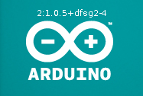

**As of this writing (20190915) Teensyduino 1.47 supports Arduino versions 1.0.6 and 1.6.5-r5 and 1.8.1 and 1.8.5 and 1.8.7 and 1.8.8 and 1.8.9.**

Go to <https://www.arduino.cc/en/software>

Look for  which is a tar file; After download right click downloaded arduino installer and extract

7/3/22 Installing Arduino on Ubuntu 20

<https://linoxide.com/how-to-install-arduino-ide-on-ubuntu-20-04/>

$ sudo apt-get update

$ sudo apt-get upgrade

$ mkdir arduino

$ cd arduino/

$ wget https://downloads.arduino.cc/arduino-1.8.19-linux64.tar.xz

$ tar -xvf ./arduino-1.8.19-linux64.tar.xz

$ cd arduino-1.8.19/

$ sudo ./install.sh

$ /home/tractor/arduino/arduino-1.8.19/hardware/teensy/avr/cores/teensy4

$ sudo make

| wget https://downloads.arduino.cc/arduino-1.8.15-linux64.tar.xz  wget https://www.pjrc.com/teensy/td_154/TeensyduinoInstall.linux64  wget https://www.pjrc.com/teensy/00-teensy.rules  sudo cp 00-teensy.rules /etc/udev/rules.d/  tar -xf arduino-1.8.15-linux64.tar.xz  chmod 755 TeensyduinoInstall.linux64  ./TeensyduinoInstall.linux64 --dir=arduino-1.8.15  cd arduino-1.8.15/hardware/teensy/avr/cores/teensy4  make |
| --- |

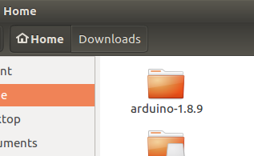

* Extract the downloaded Arduino File
* Move it the extracted folder to the Home directory
* Open install script with sublime; Search for RESOURCE_NAME - not sure why, just look at it. (e.g. /home/al/Downloads/arduino-1.8.9/install.sh)



* $ cd arduino-1.8.13 # cd to the Arduino directory and run the install script
* $ sudo ./install.sh
* Copy the downloaded udev rule $ sudo cp /home/al/Downloads/49-teensy.rules /etc/udev/rules.d/
* $ cd Downloads/
* Make the downloaded Teensy Install executable.
* $ chmod 755 TeensyduinoInstall.linux64
* Execute install script $ ./TeensyduinoInstall.linux64

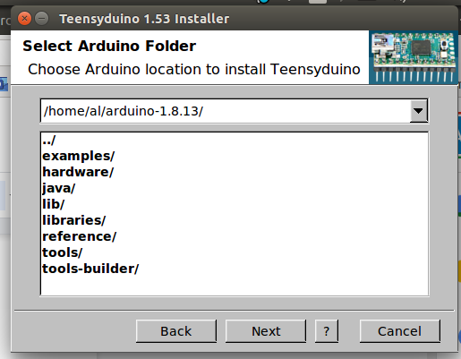

* Start Arduino IDE
* Plug in Teensy
* Make sure correct board is selected
* Upload Blink

Blink works but output to serial monitor is not working

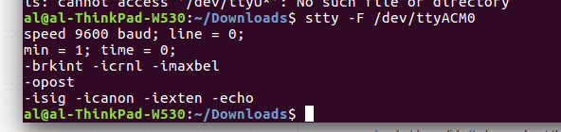

7/28/21

When installing Arduino on Ubuntu 20 I hit the following error:

Arduino: 1.8.15 (Linux), Board: "Arduino Nano, ATmega328P (Old Bootloader)"

Board at null is not available

Error downloading https://downloads.arduino.cc/packages/package_index.json

Error opening serial port '/dev/ttyUSB0'. Try consulting the documentation at http://playground.arduino.cc/Linux/All#Permission

This report would have more information with

"Show verbose output during compilation"

option enabled in File -> Preferences.

7/3/22 Installing Arduino on Ubuntu 20

<https://linoxide.com/how-to-install-arduino-ide-on-ubuntu-20-04/>

$ sudo apt-get update

$ sudo apt-get upgrade

$ mkdir arduino

$ cd arduino/

$ wget https://downloads.arduino.cc/arduino-1.8.15-linux64.tar.xz

$ tar -xvf ./arduino-1.8.15-linux64.tar.xz

$ cd arduino-1.8.15/

$ sudo ./install.sh

## **Adding user to dialout group**

Plug in Arduino board

$ ls -l /dev/ttyACM*

$ sudo usermod -a -G dialout al // “al” being my username

For ESP32 and TTGO Boards

<https://randomnerdtutorials.com/installing-the-esp32-board-in-arduino-ide-windows-instructions/>

* Update preferences
* Install board manager